# Caremark.com – Access Denied / Error 15 (External-Members only)

[Informational Overview](#_Toc167282646)

[Troubleshooting](#_Toc167282647)

[Related Documents](#_Toc167282648)

**Description:** This document describes how to assist members receiving an Access Denied / Error 15 message when signing in on Caremark.com.

|  |
| --- |
| Informational Overview |

Some members have reported receiving an **Access Denied** / **Error 15** message when signing in on Caremark.com.

 Do **NOT** refer callers to their client’s web support for issues outlined within this document.

This error message indicates that the member’s IP address or Internet Server Provider is being blocked by our security vendor. We have been advised that due to increased security monitoring and measures in place, certain Internet Service Provider’s (ISP’s) and IP addresses may be blocked to protect CVS digital resources from malicious attacks. Global security monitors all security threats daily.

**Figure A – Error Code 15 Error Message**

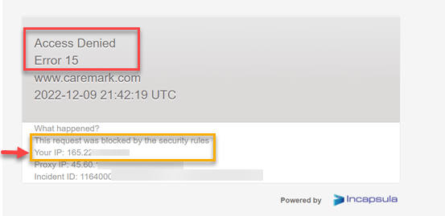

|  |
| --- |
| Troubleshooting |

1. **If a member is receiving the Access Denied / Error 15 message:**

**Is the member using a VPN (Virtual Private Network) when signing in on Caremark.com? Note:** VPN’s are typically associated with anti-virus software packages; **Example:** Norton, McAfee.

* **If so,** ask the member to disconnect from their VPN, clear their cache, and try signing in again. Members can also try using another browser such as Chrome, Firefox, Edge, or Safari (if using an Apple device).
  + In general, members can check the **Network & Internet Settings** on their device to access and change the VPN status.
  + A VPN may also be active within security/Antivirus software on the device (Norton, McAfee, NordVPN etc.) The member can be directed to contact their Antivirus software provider for specific instruction on VPN usage.
* **Alternative Options:**
  + Ask the member to try rebooting/restarting the device.
  + Advise VPN users to try signing in from another device such as their mobile phone using the Caremark App without using Wi-Fi.

1. **If the issue persists after disconnecting from the VPN, you must obtain the member’s IP Address:**

* **No Exceptions:** The member's external IP address is necessary for further troubleshooting.
  + The IP address is shown from the Access Denied / Error 15 message the member is receiving.
  + If the member is not able to provide their IP address by referencing the message, direct them to the website **https://IP4.ME** or ask them to type **“what is my IP”** in their web browser (IP addresses beginning with 10.\*, 192.168.\*, 172.16-31.\*, and 169.254.\* are all internal only IP’s and cannot be used for troubleshooting).

The member’s external IP Address is needed.

1. **Submit a Web Error Form. Refer to**: [Caremark.com – Web Error Form Process (Commercial and MED-D)](https://thesource.cvshealth.com/nuxeo/thesource/#!/view?docid=a082ab2a-cbb5-4803-a27a-339f8c30cac9) or [Caremark.com - Web Error Form Process (Vendor Teams Only)](https://thesource.cvshealth.com/nuxeo/thesource/#!/view?docid=97f7ff71-4831-453d-b292-183506cab4d2)

**Complete all the fields on the Web Error Form, including the member information.**

In the **Issue Description** fieldof the form, the following details **must** be provided:

1. Device type or path the member is using when accessing Caremark.com (**Example:** desktop, mobile site).
2. IP address shown from the Access Denied / Error 15 message.
3. Browser(s) used or tried, i.e., Chrome, Firefox, Edge, or Safari (if using an Apple device).
4. Browser extensions used (if applicable) and any other relevant information the member can provide.
5. Advise if member disconnected from their VPN (if applicable), but member continued to receive Error 15.

 **Note: If the above details are not provided when submitting a web error form, you will be required to call the member back to obtain the needed information.**

|  |
| --- |
| Related Documents |

[Computer-Related Abbreviations, Definitions, and Terms](https://thesource.cvshealth.com/nuxeo/thesource/#!/view?docid=98692d3d-3243-4173-97dd-2a65860329d1)

**Index:** [Caremark.com - Work Instruction/Job Aid Index](https://thesource.cvshealth.com/nuxeo/thesource/" \l "!/view?docid=8a2da44a-6336-454d-8deb-fca4a71ad69b" \t "_blank)

[Top of the Document](#_top)

Not To Be Reproduced Or Disclosed to Others Without Prior Written Approval

**ELECTRONIC DATA = OFFICIAL VERSION / PAPER COPY = INFORMATIONAL ONLY**